U-Storage User’s Manual

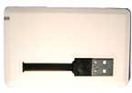
Version 3.0

Note:
OTI reserves the right to make any changes without further notice to any products herein.
How to reach us:
OURS TECHNOLOGY INC.
1F, No. 85, Kung-Ming 6th Rd., Jubei City, Hsin-Chu Hsien, Taiwan, R.O.C.
TEL: +886-3-553-7511 FAX: +886-3-555-5804

Introduction
Thank you for purchasing the U-Storage device. This manual explains how to use the application software of the device.

Safety Precautions
Please follow the safety precautions carefully before you use the U-Storage device. Make sure that you use the device correctly according to the procedures described in this manual.

Warnings This mark indicates topics that could lead to serious injury to your body or damage to the device if ignored or handled incorrectly.

___________________________________________________________________
Warnings
_____________________________________________________________ ________
- Do not attempt to disassemble or alter any part of the device that is not described in this guide.
- Do not allow the device to come into contact with water or other liquids. In the event that water or other liquids enter the interior, immediately unplug the device from the computer. Continued use of the device may result in fire or electrical shock. Please consult your product distributor or the closest support center.
- To avoid risk of electrical shock, not do the plug and unplug operations with wet hands.
- Do not place the device near a heat source or expose it to direct flame or heat.
- Never place the device close to equipment generating strong electromagnetic fields. Exposure to strong magnetic fields may cause malfunctions or data corruption.

System Requirements
There are minimum hardware and software requirements that must be satisfied to ensure the device to function properly.
- Computer Model IBM PC/AT Compatible, Power Macintosh, PowerBook, iMAC or iBook
- Operating System Windows 98 Second Edition, Windows Millennium Edition (Windows ME), Windows 2000, Windows XP, Windows 2003 Server, Linux 2.4 or higher, Mac OS 9.0 or higher
- Interface USB
- Free Hard Disk Space No less than 3 MB
  - Windows 98 SE does not support default Mass Storage Driver. You have to install the driver bundled with the device.
  - The application software can only run on Microsoft Windows OS.
  - However, the U-Storage basic functions can be supported with all the operating systems listed above.

Guide to Components

USB Interface: The interface connects to the USB port of the computer.
LED Display: This LED Display will show the status of the device. Once the device is in operation, the LED will be turned on.

Basic Functions
- Plug and Play
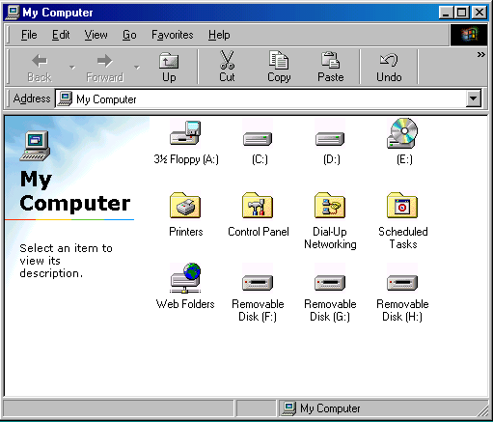

When you plug the device into the USB port of your computer, you will see a “Removable Disk” icon in the file manager window. In Macintosh, once you plug the U-Storage into the USB port. You can see the disk icon in the “Desktop”.

In Linux OS, you can mount the device by the following instructions.
■ Execute cd /etc/sysconfig/ ( cat /etc/sysconfig/hwconf | more )
■ Check the device information in hwconf，write down the mount point.
■ Make a directory in /mnt (ex: mkdir /mnt/usbHD )
■ Then, execute mount /dev/sda1 /mnt/usbHD (if mount point was .dev/sda)

- Read and Write
You can retrieve or store files in the device as a hard disk. The read/write operation of the device is the same as that of a hard disk.

- Write-Protect Switch
When you push the write-protect switch to the “ON” position, you cannot write any data into the device. But you still can read the data in the device. The “Write-Protect” switch can be moved even you do not disconnect the device. Due to Linux OS limitation, the write-protect switch will not work on-line.

- Unplug
To minimize risk of data loss on Windows ME and 2000, please follow the safe removal procedure . You can find the safe removal icon in your computer’s notification area.

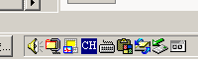

Double click the “safe removal” icon; the “Unplug or Eject Hardware” window will pop up. You can select the device you want to remove. Then, click the [Stop] button. After that you can unplug the device from the USB port of your computer.

Warning Before removing the U-Storage device, make sure the LED is not flashing. When the LED flashes quickly, there is some traffic going on between the host computer and the U-Storage device. Don’t remove the U-Storage at this moment. Otherwise, it may cause some damages to the data or even the U-Storage device itself.
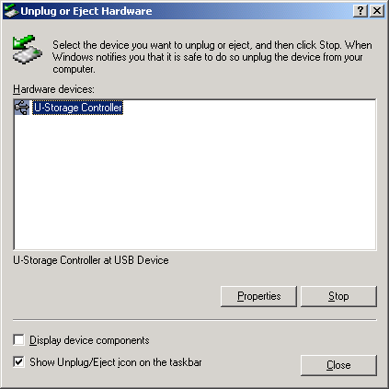
Warning If you do not follow the safe removal procedure on Windows ME and Windows 2000 operating systems, data loss caused by the “write cache” issue may happen.

On Macintosh operating systems, you can drag the removable disk icon into the trash. This action will perform the “Eject” function.

On Linux operating system, please follow the “umount” procedure to un-mount the device.

Partition Type
With U-Storage application software, you can protect your device with password log-in and partition your device into “Public” and “Security Areas
1. Public Area There is no password protection to this area. You can do any basic functions, described in the “Basic Functions” section, in this area.
2. Security Area This area cannot be accessed without security log-in. Once you log in, the device will be switched from “Public Area” to “Security Area”. After successful switching, you can do any basic functions, described in the “Basic Functions” section, in this area.
          - You can only view either “Public Area” or “Security Area” at the same time in the same disk logic unit number (Drive).

In U-Storage, you can partition the storage area of your device into any one of the following:
1. Public Area Only (Single Partition)
Make the entire device accessible to everyone.

2. Security Area Only (Single Partition)
Partition the device into two areas in one Drive: Public Area and Security Area. The Public Area is read only. The Security Area can be accessed only with a correct password.

3. Public and Security Area (Dual Partition)
Partition the device into three areas in two Drives: Public Area and Security Area in Drive1, and Public Area in Drive2. The Public Area in Drive1 is read only, while that in Drive2 is not.

Please refer to the figure below.

Public Area(Read only)
Security

Area
Change View
Through
Login & Logout

Drive1
This figure shows detailed operations of single Drive.

Public
Area(Read only)
Security

Area
Public

Area
Change View
Through
Login & Logout

Drive1
Drive2

This figure shows detailed operations of multiple Drives.

Function  Type | Security | Public area read only | Password | Disk Logical Unit Number | Disk Letters in OS
Public Area Only | No | No | No | 1 (Drive1) | 1
Security Area Only | Yes | Yes | Yes | 1 (Drive1) | 1
Public and Security Area | Yes | Yes | Yes | 2 (Drive1&2) | 2
This table describes the functions of the three partition types.

Use the U-Storage Software
On the Windows Platform
Install the USB Driver:
- On Windows 98 SE, you need to unplug and re-plug the U-Storage device after installing the driver.
For Windows NT systems, users should log on as the Administrator to use this program.

Use U-Storage the First Time:
Warning U-Storage.exe can only handle one device at the same time. If otherwise, the U-Storage.exe may not perform properly or even cause data loss.

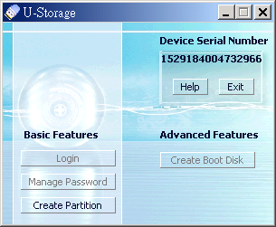
By default, the device is non-security. So, the “Create Partition” function will be active when you run this software the first time.

U-Storage - Create Partition:
You can do the [Create Partition] action to your U-Storage.

Warning The [Create Partition] action will erase all the data in the device. The action is not reversible. If necessary, back up your data before taking this action. Also, please close all the active programs and windows on the screen of your computer.

- Click the [Create Partition] button in the U-Storage manager window. The following “Create Partition” window will pop up.

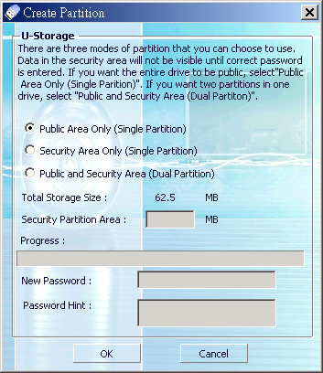

- Select the partition type you want.

- If you select the “Security Area Only (Single Partition)” or “Public and Security Area (Dual Partition)”, you can set the password for accessing the security area in the “New Password” window. The maximum length of the password is 8 characters. You can key in a hint for your new password in the “Password Hint” window. This hint will be displayed when you click the “Hint” button in the “Login” window. The maximum lenght of the Hint is 32 characters. After you finished the setting, click the [OK] button. The “Confirmation” window will pop up.
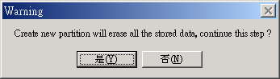

- Once the resizing is finished, the following message will pop up.
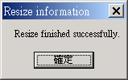
When the following message pops up, please replug the device.
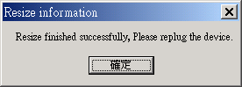

- After you finish the “Create Partition”, the “U-Storage.exe” program will be copied into the “Public Area (Drive1)” automatically.

Login the Security Area:
If you partition the device with security, you can execute the following “Login” function to access the security Area.
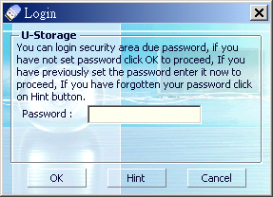

Warning When you do the login and logout actions with the device, please make sure there is no application or program running or document unclosed on the device. Otherwise, it may cause data loss or damage.

- Key in the password in the “Password” area.
- You can create the password hint in the [Create Partition] or [Manage Password] functions. Once you create the password hint, you can click on the “Hint” button in the “Login” window to help you recall the correct password. The hint will be shown for three seconds.

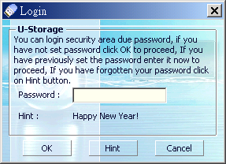

- You have three tries to input the password. After three tries, the following message will pop up. And you have to unplug and plug the device in order to do other actions.

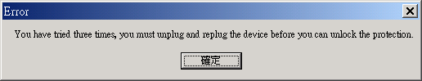
- Click on the [OK] button.

Logout the Security Data Zone:
There are three methods to logout security area:
    - Click the right mouse button and select U-Storage in the notification window, and select [logout] to exit the security area after the following window pops up

Warning When you do the login and logout actions with the device, please make sure there is no applications running or documents unclosed on the device. Otherwise, it may cause data loss or damage.

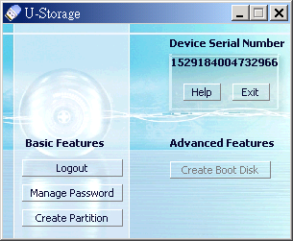
    - Click the right mouse button and select [Logout] or [Exit].

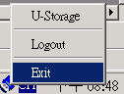

    - Double click the U-Storage icon in the notification window.

Manage Password:
User can change password and key in the password hint by selecting the “Manage Password” function in the U-Storage main window. You can only select this item when the security area is activated.

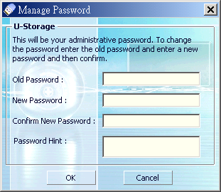
- Make sure the “Write Protect” switch is at “OFF” location.
- Key in your current password in the “Old Password” area.
- Then, key in your new password and confirm in the “New Password” and “Confirm New Password” area. The maximum length of the password is 8 characters.
- You can key in the hint of your new password in the “Password Hint” window. This hint will be displayed when you click the “Hint” button in the “Login” window.

Create Boot-Up Function
The Boot Up program in the U-Storage manager window will build up the device as a bootable disk. Before you run the program, please take the following steps:,
- This program can run on Windows 98 SE, XP, and ME. (The program can’t be supported on Windows 2000.)
- Please turn off the anti-virus program during the procedure.
- Make sure the “write-protect” switch is at “OFF” position.
- This program only deals with one device at the same time.

When you are ready to process, follow the following procedures. The procedures for Windows XP are different from those of Windows 98 and ME. This program cannot be run on Windows 2000.

Windows 98 SE and Windows ME:
- You can click the [Create Boot Disk] button in the U-Storage manager window.

- The following window will pop up
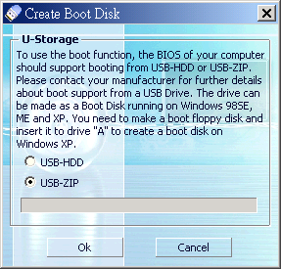

- You can select either one of the boot-up methods: USB ZIP or USB HDD. The USB HDD is only for Windows 98.
- If you select “USB HDD”, the computer will get the ” C：\>_” prompt after you boot it up from the U-Storage utility.
- If you select “USB ZIP”, the computer will get the “A：\>_” prompt after you boot it up from the U-Storage utility.

- After the selection, click the [OK] button. The following warning message will be shown. All the data in the device will be erased. If it is OK, click the “OK” button to continue the process.
Warning The program will do the formatting. The existing data in the “Public Area” will be erased.

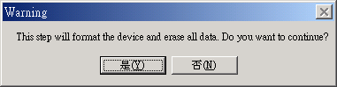
- After the process is completed, please replug the device.

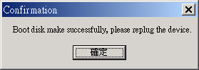

Windows XP:
- Please make a bootable floppy first. You can insert a floppy into the floppy drive. Then, click on the icon of 3.5” floppy in the “My Computer” window by using the right button of the mouse. Select the “Format” item.

- Select the item for making a bootable floppy in the format options. Then, click on the [Start] button.

- Insert the floppy disk in your drive “A” floppy disk.

- Then press [OK] button to create your boot disk.

Error Messages:
The following message means the device is set to “write protect”, please switch to disable.
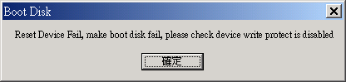
On Windows 98 and ME, if some files can not be found from the source folder, please use floppy disk to make a boot disk and copy all the files(including the hidden files) to %Windows% \COMMAND\EBD\ and try again.
(%Windows% means your Windows location.)
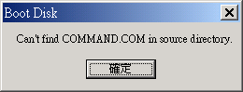
Notes:
- After you finish the program, you will see different disk property when you select different disk type. For example, if you select it as “USB HDD”, you will see the hard disk icon in the file manager window. If you select it as “USB ZIP”, you will see the removable disk icon in the file manager window. However, only Windows 2000 and above can identify the difference. In Windows 98, you just can see the “Removable Disk”.
- After you finish the program, the device contains the files necessary for boot up function. Please don’t remove any file in this area. Otherwise it will cause failure when you do the boot up procedure of your computer.
- When you want to use the U-Storage to boot up your computer, please select the appropriate setting of the BIOS. Please refer to the user manual of the motherboard.
- Since the BIOS design of each motherboard is quite different, we cannot guarantee the boot up device is suitable for every computer.
- Since Award changed their BIOS specifications in March 2002, the boot up procedure has been different. We cannot identify if the BIOS is new or old. So, this boot up utility is not suitable for Award’s new BIOS if you use USB ZIP boot up option.

Recover Disk
You can use the Recover Disk program to repair your device. This program will initialize your device if it can be recognized by the OS. If your device cannot be recognized by the OS, please contact with your manufacturer.

- After you launch the program, the following window will pop up.
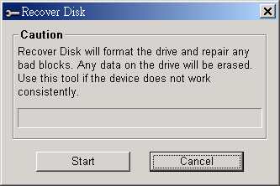
Warning The “Recover Disk” action will erase all the data or files existing in device. The action is not reversible. You have to backup all the important files or data.

- After you click the [Start] button in the window, the Recover process will be started.
- Once the job is finished, the complete message will be shown in the middle area, or else it will show error message.

FAQ
Do I need to format the drive before using it the first time?

No, the device has been pre-formatted.

Why can't I write data into the public area when the security area is activated?

The public area will be set to read-only mode when the security area is activated. The purpose is to prevent the security utility from being deleted accidentally.

Why my second partition absent in Windows 2000?

Because original Windows 2000 doesn't support multiple partitions, you must upgrade your OS to service pack 3 or above.

How to boot up from USB-ZIP and USB-HDD?

After making the boot device, you should set your first boot order to USB-ZIP or USB-HDD in BIOS. The main board of your computer must support these boot functions. You should first plug-in your boot device, then set up your BIOS.

Known Problems
Problem 1: The “Write-Protect” switch cannot work on-line on Macintosh computer with Mac OS 10.1.4.
Warning If you switch the “Write-Protect” on-line with Mac OS 10.1.4, it will hang up the computer system g when you do the read or write operation.

Workaround: Disconnect the device when you need to switch the “Write-Protect” with Mac OS 10.1.4. We will solve the system hang-up problem in the near future. However, due to the OS operation issue, we don’t recommend you to move the “Write-Protect” switch on-line.

Disclaimer
We made every effort to ensure that the information and procedure in this guide is accurate and complete, no liability can be accepted for any errors or omissions. Ours Technology Inc. (OTI) reserves the right to make any changes without further notice to any products herein.

Trademark Acknowledgments
- IBM is a registered trademark of international Business Machines Corporation.
- iBook and iMac are trademarks of Apple Computer, Inc.
- Macintosh, PowerBook, Power Macintosh are trademarks of Apple Computer, Inc.
- Microsoft, Windows, Windows 98, Windows ME, Windows 2000, Windows XP, and Windows 2003 Server are either registered trademarks of Microsoft Corporation in the United Stats and/or other countries.
- Other names and products not mentioned above may be registered trademarks of their respective companies.

