USB2.0 Mass Storage Disk
OTi2168
Win98 & Win98 SE Installation Guide

- Insert the CD-ROM supplied.

- Double click the Win98Driver1.24.exe program.

- Follow the on-screen instructions that are displayed on the screen

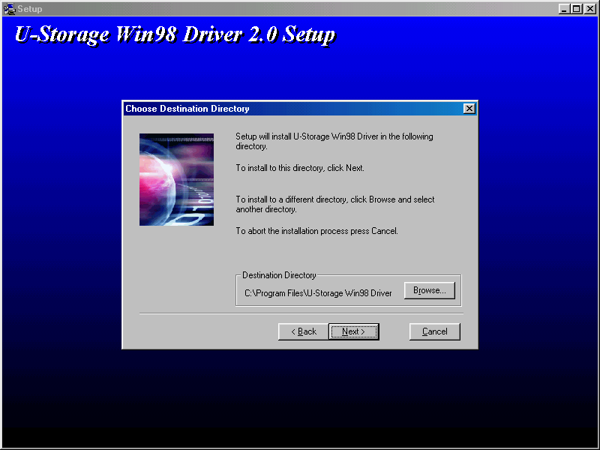

- To install , click “ next> ” . Follow the on-screen instructions that are displayed on the screen.

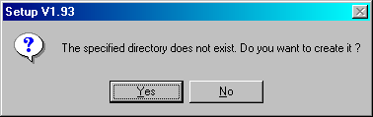

- Click “ Yes ” to install the driver. The follow the instructions displayed on the screen.



6) Once set-up is complete insert your USB Mass Storage Disk into USB port, using the supplied cable if required.

- Finally, unplug and then re-plug the device.

Disclaimer
We made every effort to ensure that the information and procedure in this guide is accurate and complete, no liability can be accepted for any errors or omissions. Ours Technology Inc. (OTI) reserves the right to make any changes without further notice to any products herein.

